**Name : Yahia Ahmed Hussein Gouda Sherif**

**B.N : 1133**

**Date : 11/6/2021**

**Topic : Artificial Intelligence**

**Github link : https://github.com/YahiaElsherif/artificial-intelligence-html-project**

## **Application Brief : I used the application ( Visual Code Mobile), It’s easy to use and so simple and integrated. I didn’t face any kind of problems while I was using it. It’s so fast and so effective and I advise everyone to use that application.**

## **Screenshots :**

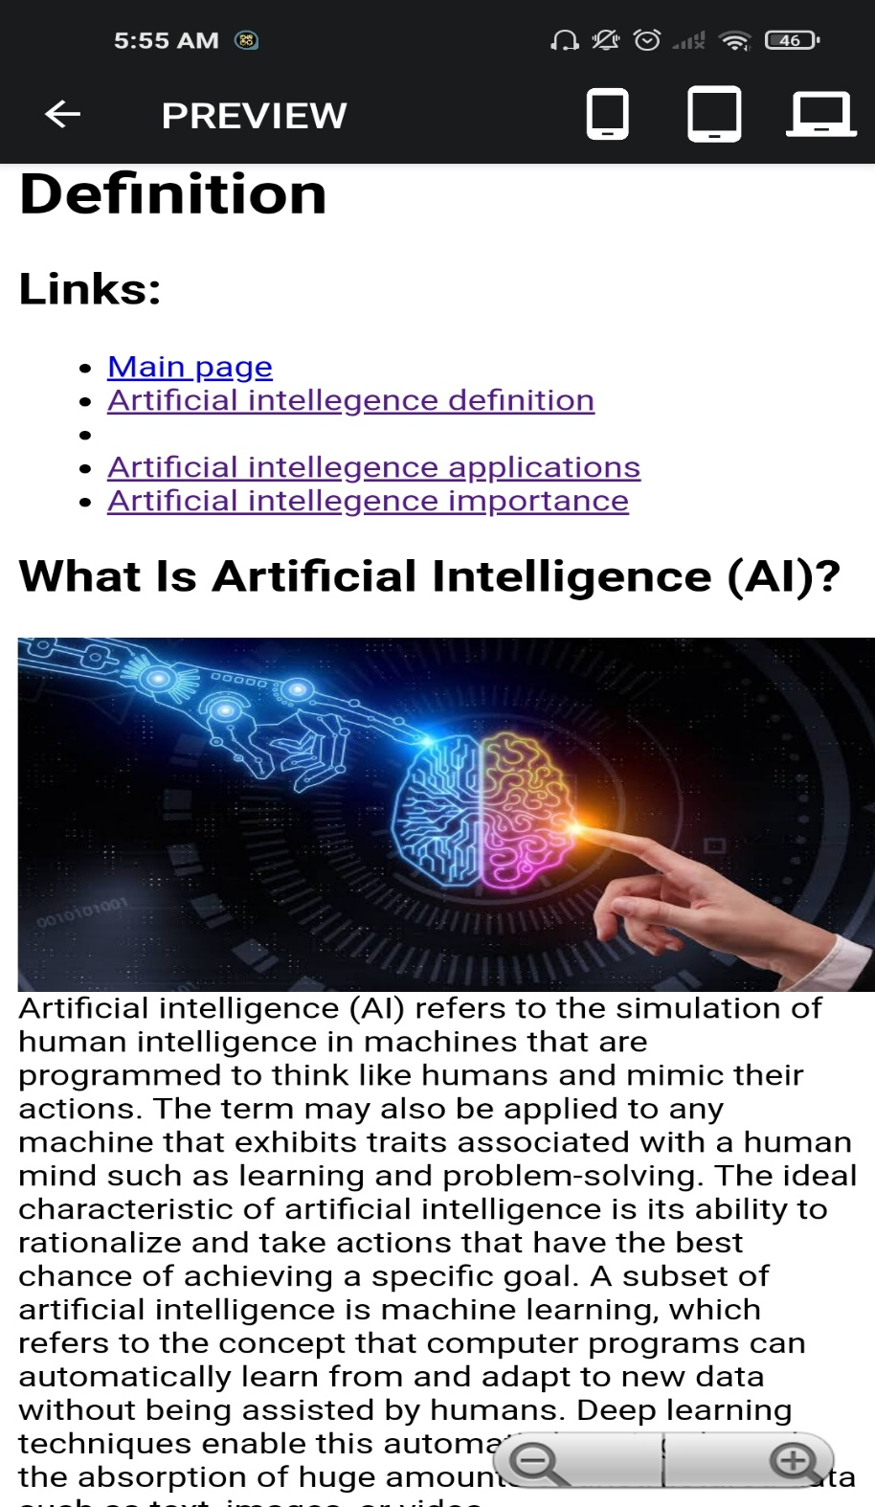

## **Source code :**

